
Dhaka International University
Lab Report details:
Lab Report Topic : Constructors and Methods Understanding, Understanding Static and Instance Methods
Lab Report No :05
Course Title : Object-Oriented Programming Languages
Course Code : 0613-202

Submitted By: | Submitted To:
S M Nabil Ausaf  Roll: 01  Reg No : CS-D-91-23-124492 | Prof. Md. Abdul Based

Date of Submission: 11 Nov 2024

Lab Report: Constructors and Methods Understanding in Java
Objective
The objective of this lab is to get an understanding of how constructors work in Java and how they are used for the initialization of objects. We also shall explore the concept of invoking a method within the same class.
Components Used
1. Java Development Kit (JDK): Version 8 or higher.
2. IDE: Eclipse, IntelliJ IDEA, or any text editor that can compile programs on a command line
3. Operating System: Windows, macOS, or Linux
4. Java Runtime Environment: to be installed for running Java Programs.
Theory
In Java the constructor is a special method that gets called when an object is instantiated. A constructor has a few characteristics:
It shares the exact name of the class. Constructors do not have a return type, not even void. A constructor is used to initialize an object, typically by setting initial values into instance variables.
A method, on the other hand is used to define behaviors or actions for objects. Methods can be called on objects of a class to perform certain tasks. In this lab we use a constructor and a method to print out specific messages when the class is instantiated and a method is called.

Code
Following is the code that defines a class, constructor, with a constructor and a method M():
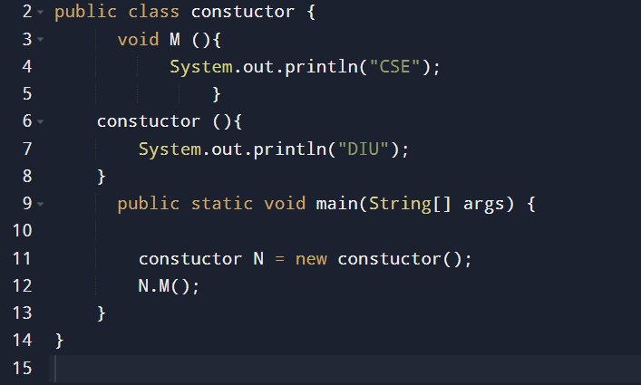
Class Declaration: The access modifier is public class followed by the name of class that is constructor
Method M(): Inside this class, there is a method, void M() . When called, it outputs to console CSE
Constructor “constuctor()”: In Java, every class has to have a constructor with the same name as that of the class. This constructor prints DIU when the object of the class is instantiated.
Main Method: In Java, this is the main entry point for every program that is written in Java. It creates an object of constuctor and calls the method M() on it.
Discussion
This program will execute as follows:
- Constructor Invocation: In the line constuctor N = new constuctor(); , a new constuctor is created.
- The constructor constuctor() is called automatically when an object is created.
- Due to that, DIU is printed in the console.
- Method Invocation: Once the object gets instantiated, the method M() will be invoked through the object reference N using the line of code N.M(); .
This prints CSE to the console.
This program demonstrates the very basic functionality of a constructor and how methods are invoked on class instances. The constructor is invoked implicitly when the object is created; whereas, the method M() must be explicitly invoked on the object.

Output
The expected output of the program is:
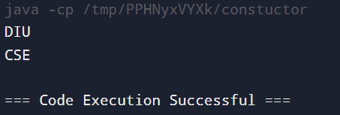
Explanation of Output:
DIU is displayed by the constructor constuctor() when any object is created.
CSE is printed when the method M () is called explicitly on object N
Conclusion
This lab really demonstrated how to make use of constructors and methods in Java. We could notice how a constructor is invoked automatically when an object is created and how different it was from the usual method. Constructors and their use in initializing objects form a very basis in Java; this is how the developer is capable of creating initial states and configurations for objects in efficient ways.

Lab Report: Understanding Static and Instance Methods in Java
Objective
The objective of this lab is to understand the differences between static and instance methods in Java. Particularly, we see the interaction of static methods with the static variables, the capability of instance methods to access both static and instance variables, and how each kind of method is called.
Components Used
1. Java Development Kit (JDK): Version 8 or higher.
2. IDE: Eclipse, IntelliJ IDEA, or any text editor that can compile programs on a command line
3. Operating System: Windows, macOS, or Linux
4. Java Runtime Environment: to be installed for running Java Programs.

Theory
Methods are of two flavors in Java, either as static or instance methods (non-static):
Static methods are developed using the keyword static. The method, in this case, belongs to the actual class and not to any of its instances. So, static methods can be invoked without the creation of any instance of the class. They can directly access only static variables, but not instance variables.
Instance methods are those specific, belonging to an object of the class. In order for the program to invoke this instance method, it needs to instantiate an object of that class first. Instance methods can access both static variables
Code
The following program demonstrates the application of static and instance methods:
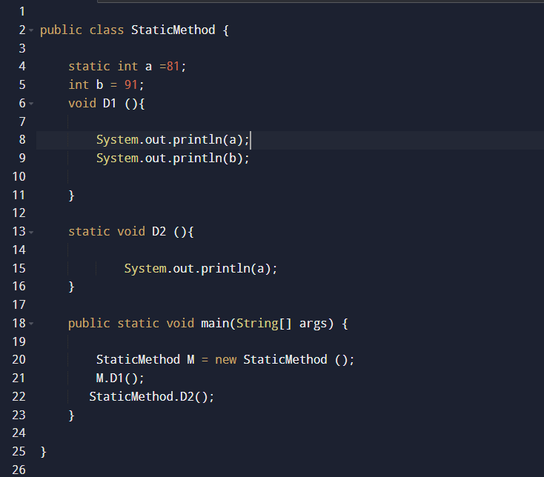
Explanation
1. Class Declaration: public class StaticMethod declares the class by the name StaticMethod.
2. Static Variable a: static int a = 81; declares a static variable 'a', which will be common for all objects of the class.
3. Instance Variable b: Declaration int b = 91; is an instance variable. Each object of type StaticMethod will have their local copy of b.
4. Instance Method D1(): The method D1() is an instance method which:
- Prints the value of the static variable a.
- Prints the value of the instance variable b.
5. Static Method D2(): In the following method, D2() is a static method that does the following:
- Prints the value of the static variable a.
- Because D2() is static, it doesn't have access to an instance variable b. It will only print a.
6. Main Method: Here comes the entry point method of the program:
- Creates an instance of StaticMethod called M.
- It calls the instance method D1() on M, which reads both a and b.
- It calls the static method D2() on the class, not the instance, which reads only the static variable a.
Discussion
This program does the following when run:
Object Creation: StaticMethod M = new StaticMethod(); It creates an instance M of the class StaticMethod.
Invocation of Instance Method D1(): M.D1(); It invokes a method D1 on instance M.
D1() can write both the static variable a shared among all instances and the instance variable b private to each instance.
Consequently values 81 for a and 91 for b are written to the console.
Calling Static Method D2(): StaticMethod.D2(); calls the method D2 directly from the class StaticMethod.
Since D2() is a staticmethod it has direct access only to static variable a.
The value 81 for a is written to the console.
Output
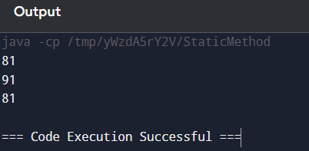

Explanation of Output:
- 81: Printed by D1() as it accesses the static variable a.
- 91: Printed by D1() as it accesses the instance variable b.
- 81: Printed by D2() as it accesses only the static variable a.
Conclusion
This lab is successfully implementing the concept of static and instance methods in Java. This program illustrated that:
1. The instance methods have visibility to both static and instance variables.
2. The static methods access directly only static variables, not instance variables.
3. Static methods are invoked directly on the class, while instance methods are invoked on object instances.
This is important to know during class design when there could be common resources through static variables and methods but individual instance behaviors.

